

|  |  |
| --- | --- |
| **Student Name** | **Arun Adhikari** |
| **SRN No** | 202100406 |
| **Roll No** | 38 |
| **Program** | Computer Engineering |
| **Year** | Third Year |
| **Division** | G |
| **Subject** | Computer Network Laboratory (BTECCE21506) |
| **Assignment No** | Seven |



Assignment Number - 07

**Title :** Installing and configuring DHCP server for Linux/Windows.

**Problem Statement :** Set up and configure a DHCP (Dynamic Host Configuration Protocol) server on a Linux or Windows system to automate IP address assignment for devices on a network.

# Theory :

The Dynamic Host Configuration Protocol (DHCP) is a network management protocol used to

dynamically assign IP addresses and other network configuration parameters to devices on a network. This automation simplifies network administration by eliminating the need for manual IP address configuration on each device. The DHCP server centralizes IP management, allowing for more efficient IP address usage and reducing configuration errors.

# Key Concepts:

1. **DHCP Server :** This is the device or software responsible for assigning IP addresses to clients on the network. The server maintains a pool of IP addresses and other network configuration

parameters such as subnet mask, default gateway, and DNS servers, which it assigns to clients.

1. **DHCP Client :** Any network device (such as computers, printers, or smartphones) that requests an IP address from the DHCP server. When a client connects to the network, it sends a request to the DHCP server, which then responds with an available IP address and configuration details.
2. **DHCP Lease :** The DHCP server assigns an IP address to the client for a specified duration, known as the "lease period." The client can use this IP address until the lease expires, at which point it must renew the lease or request a new IP address.

# DHCP Process:

* + **Discover:** The client broadcasts a request on the network, seeking a DHCP server.
  + **Offer:** The DHCP server responds with an IP address offer.
  + **Request:** The client formally requests the offered IP address.
  + **Acknowledge:** The DHCP server confirms the assignment and provides the network configuration details.

1. **DHCP Scopes:** A scope is a predefined range of IP addresses that the DHCP server can assign

within a network. Each scope can define additional options, such as lease duration and specific IP ranges for different subnets or VLANs.

# Benefits of DHCP:

* **Simplified Network Management**: Automatically assigning IP addresses reduces manual configuration effort and errors.
* **Efficient IP Address Allocation**: DHCP dynamically manages IP addresses, allowing reallocation of addresses when devices disconnect, making better use of the IP address pool.
* **Ease of Scaling**: DHCP supports automatic IP assignment, making it easier to expand the network by adding new devices.

# Case Study :

In this network setup, we implemented a Dynamic Host Configuration Protocol (DHCP) server to automate IP address assignment across a local area network (LAN). The goal of this project was to simplify IP management, ensure consistent network configurations, and reduce the potential for configuration errors across multiple client devices**.**

# Network Design

The network consists of a central DHCP server, client devices (desktops, laptops, smartphones), and additional infrastructure components such as switches and wireless access points. The DHCP server dynamically manages IP addresses within a specified range, and provides essential configuration

parameters like the subnet mask, default gateway, and DNS server information. Both wired and wireless clients on the network can request IP addresses from the DHCP server.

# Configuration and Implementation

1. **DHCP Server Setup:**

For this setup, we used a [Linux/Windows] server to host the DHCP service.

* + The DHCP service was installed and configured to define an IP address scope, specifying a range of addresses that can be assigned to clients.
  + The configuration included setting lease durations, defining the subnet mask, and adding gateway and DNS information to ensure clients could access both internal and external network resources.

# Scope and Options Configuration:

* + The DHCP scope was set up to provide IP addresses within a private IP range (e.g., 192.168.1.10 to 192.168.1.100).
  + Additional DHCP options were configured to assign the correct default gateway and DNS servers automatically, ensuring clients received complete network configuration details upon connection.

# Client Connections and Testing:

* + Once the DHCP server was active, each client device (desktop, laptop, and mobile device) was configured to obtain an IP address automatically.
  + We verified connectivity by performing ICMP (ping) tests to the default gateway and external addresses, confirming that each client could access the network and internet.
  + Further testing involved renewing leases and verifying that new clients received IP addresses within the defined scope without conflicts.

# Outcome and Benefits

The implementation of the DHCP server achieved the following benefits:

* + **Automated IP Assignment:** The DHCP server provided each device with a unique IP address, eliminating the need for manual IP configuration and reducing the chance of IP conflicts.
  + **Scalability:** The network can easily accommodate new devices, as the DHCP server dynamically manages IP addresses, allowing efficient use of the IP pool.
  + **Ease of Management:** Network administrators can easily modify network settings on the DHCP server, and the changes will automatically propagate to all connected clients.



# Solution :

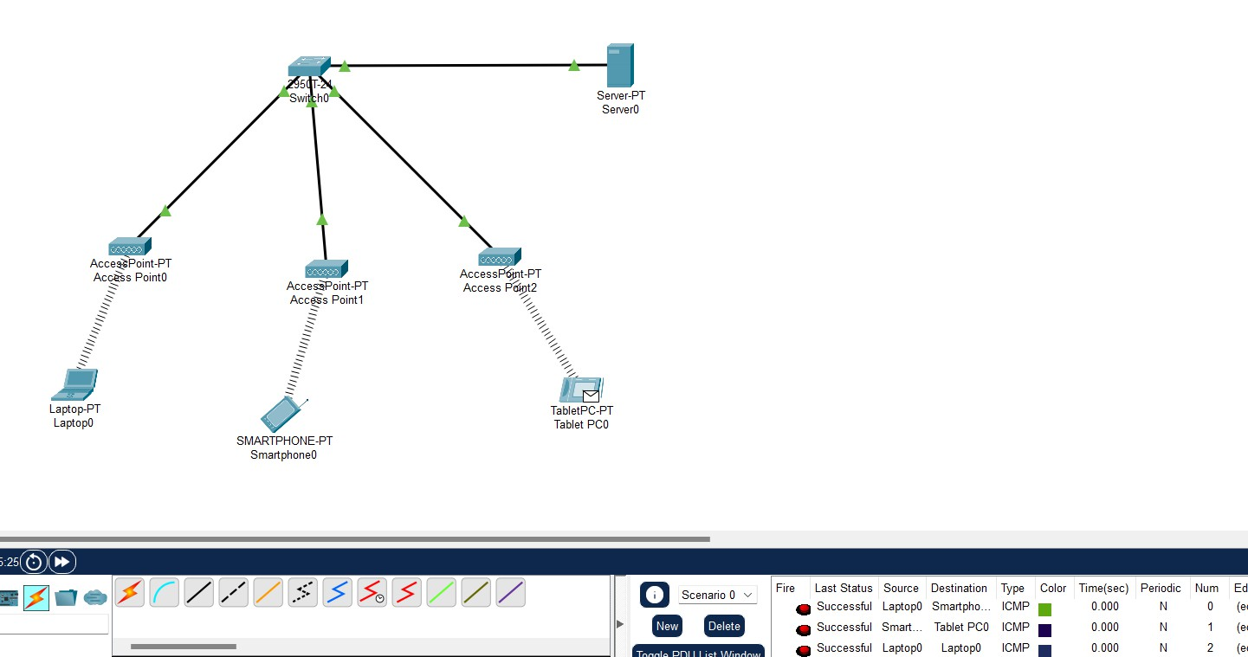

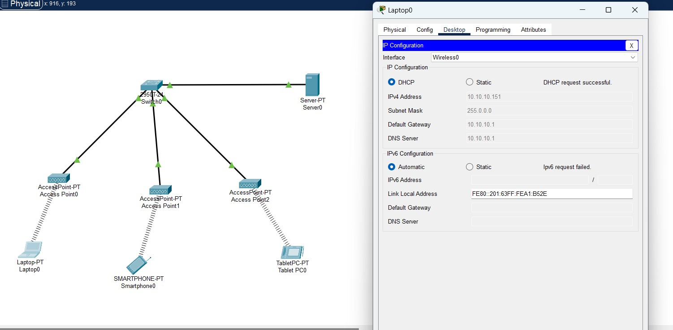





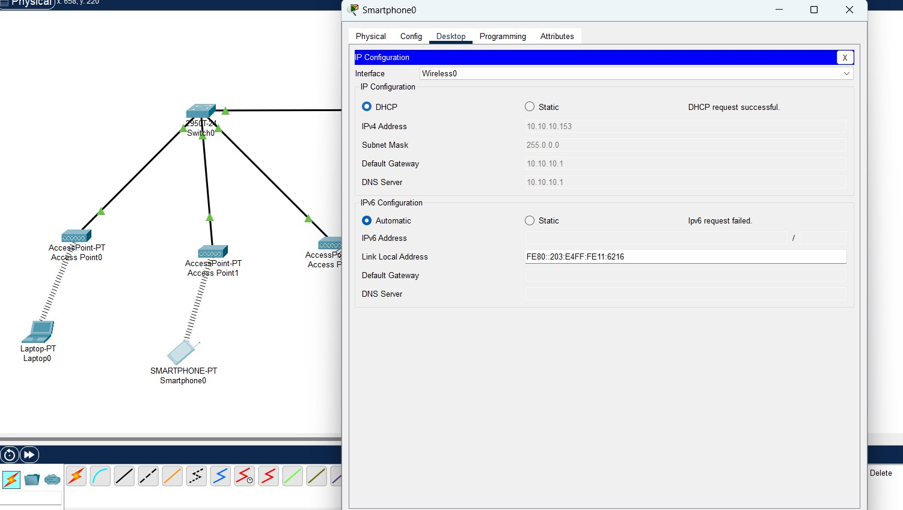



**Conclusion :**

In conclusion, implementing a DHCP-enabled network significantly streamlined IP management by automating address assignment and centralizing network configuration. This setup reduced administrative effort, minimized IP conflicts, and ensured consistent network settings across all devices. The DHCP server facilitated scalability, allowing new devices to join the network seamlessly, while maintaining reliable connectivity and efficient IP address utilization. This solution proved highly effective for managing a dynamic network environment with diverse client devices.